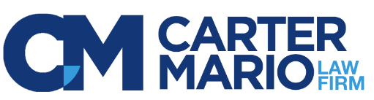
Paralegal - Personal Injury
North Haven, CT
Full-time

The Carter Mario Law Firm has been helping personal injury victims throughout Connecticut for over 30 years. We are strong and growing! Our efforts to go above and beyond have resulted in countless successful results. We are seeking an experienced personal injury paralegal to join our North Haven prelitigation team.
Responsibilities:
- Maintain and update files through all prelitigation phases
- Frequent interaction with clients in person and by phone
- Timely communication, follow up, and follow through with clients, attorneys, and medical providers
- Precise confirmation and documentation of case activity
- Obtain medical documentation, final reports, monitor liens, confirm balances
- Prepare demand packages for attorney review
- Prepare settlement statements for attorney review
- Prepare file status reviews
- Complete file opening and closing tasks
- Prepare and send correspondence
- Timely processing of daily case scans/mail
- Assist with phone coverage as needed
- Perform investigative tasks at the direction of the Attorney and/or Supervisor
Qualifications:
- Proficient in handling all stages of personal injury cases as noted above
- Minimum 3 years of consecutive personal injury paralegal experience is required
- Experience with medical record review and documentation
- AS degree in legal studies or paralegal certification preferred
- Skilled in interacting with clients in person and by phone
- Professional written and verbal communication skills (grammar, spelling, tone)
- Genuine service demeanor
- Efficient time management skills to prioritize and meet deadlines
- Detail oriented and proactive
- Team player who can also work independently
- Ability to navigate various software programs, Microsoft Office Suite, Outlook, and Adobe. Legal software experience a plus.

We recognize talent and reward results. Our benefit options include medical, dental, vision, life insurance, short-term and long-term disability, an employee assistance program, paid time off bank, and a 401(k) plan with employer matching. We provide opportunities for continued growth through on-site training, tuition assistance, and a book club.
To apply, please forward your resume to humanresources@cartermario.com

